

**Zone: Preston East: Employment & Housing Sites**

|  |  |  |
| --- | --- | --- |
|  |  | Bluebell Way – Outline planning application made for a car showroom, plus a key land acquisition by Barnfield/Henry Boot Developments to bring forward a large employment site in the short-medium term |
|  |  | Red Scar – Planning consent for a new energy plant |
|  |  | Preston East Expansion Area Land – discussions ongoing with Homes England to bring forward the site and undertake due diligence prior to taking it to the market |
|  |  | **Whittingham site** – (housing) outline planning application submitted for 750 units. (Employment) With regard employment there is currently no commercial use in the masterplan – due to a lack of market demand care home |

**Zone: Bamber Bridge**

Housing sites:

**Brindle Road** – After successfully winning their planning appeal to develop a portion of the site (193 units) Bellway are now actively building on site. A separate appeal by Persimmon was also successful and they now have planning permission for their development (261) units.

**ZONE: Preston City Centre:**

**Housing sites**: Winckley House and Cross Street - completions delayed on these sites - construction is now progressing on site.

**Employment sites:**

|  |  |  |  |  |  |  |  |  |  |  |  |  |  |  |  |  |  |  |  |  |  |  |  |  |  |  |  |  |
| --- | --- | --- | --- | --- | --- | --- | --- | --- | --- | --- | --- | --- | --- | --- | --- | --- | --- | --- | --- | --- | --- | --- | --- | --- | --- | --- | --- | --- |
| |  |  |  | | --- | --- | --- | |  |  | **Shankly Hotel, city centre –** construction underway | |  |  | **Park Hotel, East Cliff –** planning application consented | |  |  | **UClan** – continued progress on the delivery of the Masterplan, with the expected completion of the Engineering Innovation Centre in summer | |  |  | Porsche car showroom, Docks area – construction underway | |  |  | **Queen's Retail Park** – construction underway of additional retail units | |  |  | **Prince's Central Buildings** – formal discussions with the health sector are to be scheduled to map out potential project scope and key milestones | |  |  | **Preston CBD** – (Hill Street/Corporation Street) marketing ongoing for office scheme and market opportunities being explored | |  |  | **Preston Cinema** – demolition of former market hall ongoing and programme being developed to deliver the scheme | |  |  | **College House, Winckley Square** -  there has been little developer activity to support occupation | | |
|  |  |
|  |  |
|  |  |
|  |  |
|  |  |
|  |  |
|  |  |
|  |  |
|  |  |

**ZONE: Penwortham and Lostock hall: Employment & Housing sites**

**Housing sites: Land to the north and south of the Cawsey** Morris Homes are now on site. The bridge link to complete the section of the Cross Borough link road between the Cawsey and Carr Wood Way is under construction – expected to complete in autumn 2019.

**Pickerings Farm (the Lanes)** – Outline application expected in the near future further clarity expected following a meeting on 3rd July. Limited range of district centre type commercial uses expected

**Employment sites:**

|  |  |  |
| --- | --- | --- |
|  |  | Cop Lane, Penwortham – site marketing ongoing and enquiries currently being handled |
|  |  | Pickerings Farm – the masterplan doesn't include any commercial element |

**Zone: North West Preston - Housing sites:**

**Haydock Grange Hoyles Lane** – Outline permission for 450 units granted in 2012. Development commenced on Phase 1 for 205 units in Year 2, 2015, had 24 completions within the year. The majority of Phase 1 is now complete apart from a parcel containing 11 units which is currently occupied by a small number of show homes and parking for potential buyers. Phase 2, for 245 units, is now under construction.

**Maxy House Farm** – Reserved matters permission approved for a total of 300 units. The site is being built out by two developers, following sale of part of the site from Wainhomes to Bellway Homes. A total number of 55 units have been completed within year across the whole site. Bellway Homes, who are currently building out the smaller parcel at Maxy House House Farm, have built 136 units to date. Therefore, their share of the development is now complete. The other parcel, which is currently being built out by Wainhomes, had a total of 30 units completed within the year and a total of 110 to date.

**Barratt Homes Eastway** – permission for 140 units on the site. A total number of 63 units have been completed within the year, which is considerably above the projection of 36 units provided by Hive. In total, 82 units have been completed across the site since commencement at the back end of 2017.

**Employment sites:**

|  |  |  |
| --- | --- | --- |
|  |  | **Eastway** – Commencement of development on a number of sites (with a strong market demand for retail), plus a distribution warehouse and care home |
|  |  | **Cottam Hall** – developer discussions ongoing with regards new potential development |

|  |  |  |
| --- | --- | --- |
| On track | Behind target but mitigation in place | Not on track – no mitigation |

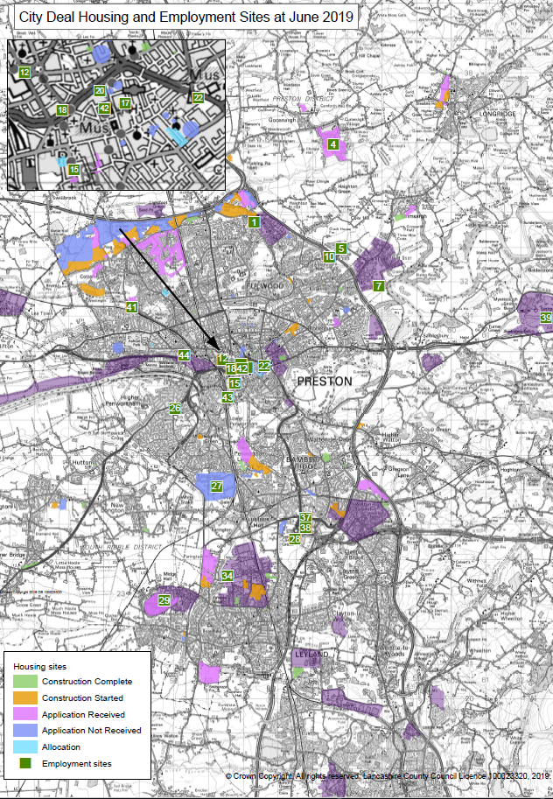

**Zone: Leyland and Cuerden**

Housing sites:

**The Southern end of Croston Road Heatherleigh** – In the southern part of the site construction has continued consistently with Miller Homes well advanced with their part of the site. In the last monitoring report it was reported that there had been difficulties with the middle section of the site to the immediate north and south of Bannister Lane which is an area of land made up of a consortium of landowners. There was a reluctance at that time on behalf of some members of the consortium to bring the site forward. An application was submitted by Kier Living for 175 units which covers the balance of the land up to Bannister Lane. This was approved by planning committee on 26 June 2019.

**Northern part of Croston Road/Heatherleigh** – This part of the site has Outline permission. In recent weeks Homes England have hosted events a series of events with the assistance of South Ribble to meet those House Builders who are potentially interested in developing out the site. It is likely that the successful developer will be able to be announced in the coming weeks. All of the roundabout works to the north of the site are complete and this will allow the construction of the spine road to serve the development to take place with each respective phase.

**Altcar Lane** – This site is split into two parcels. The parcel adjacent to Shaw Brook Road has had a Reserved Matters approval for 232 dwellings. The parcel adjacent to Altcar Lane has a current Reserved Matters application for 200 dwellings. Lovells have now commenced building out these 200 dwellings

Employment sites:

|  |  |  |
| --- | --- | --- |
|  |  | **Momentum, South Rings (Phase 2)** – preparations being made for final build out of units |
|  |  | **Samlesbury Aerospace Enterprise Zone** – start on-site made for BAE Systems' Advanced Manufacturing Facility |
|  |  | **Lancashire Central, Cuerden –** options review ongoing and M65 Terminus & Sliproad design underway |
|  |  | **Moss Side Test Track** – planning application being prepared for September. (employment and housing) |
|  |  | **Farrington Hall Estate** – site currently in the process of being disposed of |
|  |  | **Amethyst Court, South Rings** – site currently being marketed |

**City Deal Housing and Commercial Sites – Performance Dashboard - Progress and Issues – June 2019 update Appendix 2**

**Commercial floorspace**

**Floorspace completed**

Actual: sqm Target: sq m

Floorspace submitted for planning: sq m

Floorspace consented for planning: sq m

**Fig 2: Percentage of housing units with planning consent (outline or full)**

**Units submitted for planning since April 2018 = XXX**

**Units consented since April 2018 = XXX**